Analysis of Weightlifting Success Predictability Using Machine Learning
Joaquin Camaran¹, Yuna Ukawa¹, Thiago Reis¹, Christopher Taber¹, William G. Hornsby², Alex Long¹, Mehul Raval³, N. Sertac Artan⁴, Tolga Kaya¹, and Samah Senbel¹
¹ Sacred Heart University, Fairfield, CT 06855, USA
²West Virginia University, Morgantown, WV 26506 , USA
³Ahmedabad University, Ahmedabad, India
⁴New York Institute of Technology, New York, USA
{camaranj,Ukaway,reist2}@mail.sacredheart.edu, {taberc,longa9,kayat,senbels}@sacredheart.edu, william.hornsby@mail.wvu.edu, mehul.raval@ahduni.edu.in, nartan@nyit.edu
Abstract. Machine learning techniques are used extensively in sports to help optimize athletes’ performance and maximize their chances of winning. Weightlifting requires quick and calculated decision-making by the coach and athlete to determine optimal load selection when progressing through lifting attempts during competition. When an optimal load-selection strategy is employed, the probability of success in competition is maximized. An XGBOOST machine learning model was developed to predict the success of weightlifting attempts in competition. The model was trained on an extensive dataset, including the performances of more than 14,000 athletes observed throughout 11 years of competition. We also included data from the 2024 Summer Olympic Games as a test dataset. The data contained information about the athletes’ sex, age, competition weight class, previous lifting performance, and previous competition placings. The accuracy of our predictions varied among the different weight classes, with a maximum accuracy of 89% for female athletes in the clean and jerk event. The outcome of our work is that, in general, the performance of female lifters is more predictable than males. Furthermore, the performance of the athletes competing in the lightest and heaviest weight classes for each sex category is the most predictable. Interestingly, prediction accuracy differs between lift attempts and lifting events performed during competition, with the initial attempt of the clean and jerk being the most predictable.
Keywords: Machine Learning, Prediction, Sports Analytics, Weightlifting.
- Introduction
Machine learning (ML) techniques have become increasingly ubiquitous in competitive sports in recent years. Among the various applications of these analytical techniques, ML have been used in predictive modeling and relational analysis of athlete injury risk, performance optimization, competitive outcomes, optimal roster selection, and athlete rankings [1]. ML have also become pervasive in sports management and promotion, as various analytical techniques have been used to provide recommendations for ticket pricing, and even in sports betting, where ML has been used to improve predictions of competitive outcomes. The sporting applications of ML have been studied extensively in soccer [2], followed by basketball [3], handball [4], and volleyball [5] due to the immense popularity of these sports. The wealth of publicly available data has enhanced the potential use cases for ML in sports due to the potential to generate and train models that may yield relatively accurate predictions using historical performance data for individual athletes, teams, or a specific competition.
Weightlifting is a sport where athletes compete by performing two events, the barbell snatch and the barbell clean and jerk [6]. Competitors are allowed three attempts in the snatch, followed by three in the clean and jerk, to complete each movement with the greatest load possible while meeting specific standards for each movement. Ultimately, the objective is to lift the greatest load possible in each event, which is then summed to equal the athlete’s competition total. The athlete who achieves the greatest two-lift total during a specific contest is considered the victor. Therefore, the challenge of the sport is to maximize the athlete’s total by having them lift the greatest load possible in each event, within the athlete’s capabilities for that given competition day.
Weightlifting is a weight-class sport with multiple classes for males and females. Athletes endeavor to compete with the highest body weight possible under their weight class upper limit, allowing them to maximize their competition potential [7]. By choosing the appropriate weight class for their height and anthropometric characteristics, athletes optimize the amount of muscle mass they can possess in relation to their total body mass, further enhancing their ability to produce force against the external loads encountered in competition [8]. The number of weight classes in modern weightlifting has varied based on the competition year, ranging from 15 to 20 categories for males and females combined [9].
During the competition, coaches and athletes must work together strategically to determine appropriate load selections for each event, and each attempted lift to maximize the athlete’s neuromuscular and technical abilities, enabling the athlete to achieve their greatest total. Load selection for each attempted lift is heavily influenced by an athlete’s previous training and competition history, the forecasted performance expectations for each athlete determined immediately before a competition, and the athlete’s performance in each preceding attempt completed during an ongoing competition. The art of coaching during a Weightlifting meet, then, lies in the selection of optimal initial loads for each event, which are then followed by sensible increases in load with successive attempts. Appropriate determination of initial or opening loads and relevant increases in load during successive attempts during each event enables the athlete to achieve the highest possible placement in competition by successfully completing lifts at or near the athlete’s maximum ability. In Weightlifting, no standard increase in load is recommended when progressing through lifting attempts; however, considering historical performance outcomes, coaches often select a load that results in a 2-5% increase between attempts, depending on the athlete. By optimizing load selections between attempts, coaches contribute to an athlete’s potential for completing lifting attempts and achieving the intended outcome of posting the highest total possible.
In this work, A ML model was developed to analyze the efficacy of historical load selection strategies in Weightlifting to gain the critical insight necessary to provide recommendations to coaches and athletes for optimal load selection strategies during competition. The model was trained using a publicly available dataset of weightlifting performance data collected during competitions over eleven years. The model aimed to predict the optimal load lifted by each athlete observed by considering successful lifting attempts, unsuccessful lifting attempts, and load increases between attempts. Furthermore, to improve the performance of the model, athlete sex and competition weight class were also considered.
- Related Work
Ball et al. [10] presents an excellent analysis of all USA powerlifting competitions between 2012 and 2016. They study the effect of age and weight on the performance of athletes over the years, concluding that women's peak performance declines faster than men's peak performance, and women seem to reach their peak sooner than men and decline sooner than men.
A related model was developed by Chavda et al. [11] to predict the optimal performance zones for different competition levels based on the data of 15 male athletes over multiple competitions. Their objective was to predict the optimal body mass for the athletes, while we are interested in predicting the weight lift to attempt based on thousands of lifts by both male and female athletes. Also, they observe that a lighter person can generally lift a greater percentage of their weight than a heavier person. In addition, men, in general, can lift a heavier ratio of their weight compared to women.
Chau [12] presents a machine learning model based on swarm optimization to predict the competition score based on a dataset of 5500 athletes' optimal squat, bench, and deadlift records over 30 years. They established a score prediction model based on the characteristics of male powerlifters and a machine learning method. The model uses the age, body weight, weight class, best squat, best bench, and best deadlift features of powerlifters, and the WOA algorithm is used to improve the model's predictive ability.
Xiang et al. [13] also uses machine learning to predict weightlifting capacity but with a different target: to prevent injury in workers whose job demands them to lift weights. They used computer vision to determine the stressed parts of the body when lifting boxes and used a large dataset to predict the maximum weight a certain person can lift without a knee, back, or shoulder injury or strain.
Kauhanen et al. [14] showed that the relationship between body weight and lifted weight is nonlinear and developed a LOWESS-based regression model for performance normalization. They concluded that the proposed formulas could serve as an objective method to assess male weightlifters’ performance, independent of body weight, age, or skill level. This suggests that body weight’s nonlinear effect may partially explain differences in prediction accuracy across weight classes.
Our study takes a different approach from previous ML models by considering not only competition level, sex, age, body weight, and weight class but also the outcomes of prior attempts within each performance. Instead of incorporating physical attributes beyond body weight, the model focuses on attempt-specific load selections and outcomes, as well as the ratio between load increases and body weight. This approach aims to optimize load selection for the next attempt as a strategic means of improving weightlifting performance.
- Methodology
The data used in this work was collected from the public records of Weightlifting competitions at different levels between 2005 and 2016. We also collected data from the Summer Olympics 2024 to use as a test case for our prediction model. The data was aggregated into one set with 14643 rows and 24 columns for analysis as shown in table 1.

Table 1: Attributes of the Weightlifting dataset
Attribute | Description
Name | Athlete’s name
Age | Athlete age in years (13 - 64, Mean 24.12, SD 4.57)
Sex | 1 = Male, 2 = Female
Weight | Weight of Athlete in kg (42.79 - 192.14, Mean: 76.5 , SD 22.04)
Competition Level | 5 categories: Olympic(468), World (3575), Continental(6194), National (4264), and local (106) levels.
Weight class | 8 men’s weight classes: 56, 62, 69, 77, 85, 94, 105, 105+ kgs, and 7 women’s weight classes: 48, 53, 58, 63, 69, 75, 75+ kgs
Snatch1 load | Load attempted in first Snatch lift in kg (22 - 206, Mean: 108.26, SD: 34.85)
Snatch1Win | Binary value, 0=fail (24.55%), 1=succeed (75.45%)
Snatch2 load | Load attempted in second Snatch lift in kg (24 - 211, Mean: 111.62, SD: 35.27)
Snatch2Win | Binary value, 0=fail (37.77%), 1=succeed (62.23%)
SnatchJump1 | Difference between Snatch2 load and Snatch 1 load
SnatchJump1Percent | SnatchJump1 divided by the players' weight
Snatch3 load | Load attempted in third Snatch lift in kg (24-216, Mean: 113.99, SD: 35.52)
Snatch3Win | Binary value, 0 = fail (54.48%), 1 = succeed (45.52%)
SnatchJump2 | Difference between Snatch 3 load and Snatch 2 load
SnatchJump2Percent | SnatchJump2 divided by the players' weight
CJ1 load | Load attempted in first Clean & Jerk lift (25-251, Mean: 134.95, SD: 41.69 )
CJ1Win | Binary value, 0=fail (20.99%), 1=succeed (79.01%)
CJ2 load | Load attempted in second Clean & Jerk lift (28-263, Mean: 139.09, SD: 42.31)
CJ2 Win | Binary value, 0 = fail (41.47%), 1 = succeed (58.53%)
CJ Jump1 | Difference between Clean and Jerk 2 load and Clean and Jerk 1 load
CJ Jump1Percent | Clean and Jerk Jump 1 divided by the players' weight
CJ3 load | Load attempted in third Clean & Jerk lift (30-352, Mean: 141.86, SD: 42.75 )
CJ3 Win | Binary value, 0 = fail (63.1%), 1 = succeed (36.9%)
CJ Jump2 | Difference between Clean and Jerk 3 load and Clean and Jerk 2 load
CJ Jump2Percent | Clean and Jerk Jump 2 divided by the players' weight

The data required minimal cleaning. Approximately 10 records were removed due to erroneous data entry. The “Country” and “Name” fields had several instances of missing and misspelled data, but this did not affect our analysis and prediction results, as these columns were not included in the analysis.
This research aimed to help athletes and coaches select optimal load increases between lifting attempts to maximize their potential to complete each lifting attempt. Towards that end, we utilize ML to predict the success/fail of each lift based on the different fields, as well as previous lifts and their success load. Therefore, we had six values to predict, one for each lift. Table 2 shows the fields used for each prediction.

Table 2: Attributes used for predicting the success of each lift
Prediction Target | Attributes
Snatch1Win | Age, Sex, Weight, Competition level, Weight_class, Snatch1load
Snatch2Win | Age, Sex, Weight, Competition level, Weight_class, Snatch1load, Snatch1Win, Snatch2load, SnatchJump1, SnatchJump1Percent
Snatch3Win | Age, Sex, Weight, Competition level, Weight_class, Snatch1load, Snatch1Win, Snatch2load, Snatch2Win, SnatchJump1, SnatchJump1Percent, Snatch3load, SnatchJump2, SnatchJump2Percent
CJ1Win | Age, Sex, Weight, Competition level, Weight_class, Snatch1load, Snatch1Win, Snatch2load, Snatch2Win, SnatchJump1, SnatchJump1Percent, Snatch3load, SnatchJump2, SnatchJump2Percent, CJ1load
CJ2Win | Age, Sex, Weight, Competition level, Weight_class, Snatch1load, Snatch1Win, Snatch2load, Snatch2Win, SnatchJump1, SnatchJump1Percent, Snatch3load, SnatchJump2, SnatchJump2Percent, CJ1load , CJ1Win, CJ2load, CJ Jump1, CJ Jump1Percent
CJ3Win | Age, Sex, Weight, Competition level, Weight_class, Snatch1load, Snatch1Win, Snatch2load, Snatch2Win, SnatchJump1, SnatchJump1Percent, Snatch3load, SnatchJump2, SnatchJump2Percent, CJ1load , CJ1Win, CJ2load, CJ Jump1, CJ Jump1Percent, CJ3 load, CJ Jump2, CJ Jump2Percent

Then, the model was run with 18 different subsets of the data:

- All athletes (14643 athletes)
- All male athletes (9089 athletes)
- Men Weight class 56 kg only (731 athletes)
- Men Weight class 62 kg only (1041 athletes)
- Men Weight class 69 kg only (1343 athletes)
- Men Weight class 77 kg only (1458 athletes)
- Men Weight class 85 kg only (1303 athletes)
- Men Weight class 94 kg only (1198 athletes)
- Men Weight class 105 kg only (1069 athletes)
- Men Weight class 105+ kg only (946 athletes)
- All female athletes (5564 athletes)
- Women Weight class 48 kg only (684 athletes)
- Women Weight class 53 kg only (816 athletes)
- Women Weight class 58 kg only (920 athletes)
- Women Weight class 63 kg only (940 athletes)
- Women Weight class 69 kg only (836 athletes)
- Women Weight class 75 kg only (708 athletes)
- Women Weight class 75+ kg only (696 athletes)

Therefore, the model was run a total of 108 (18x6) times, each time with a different set of rows and columns. The dataset was divided into a stratified training group (80%) and a testing group (20%) for each prediction model. Due to the data imbalance of the win/fail groups in most data subsets, we used the SMOTE method to create artificial data to balance the groups.
Multiple prediction models were experimented with to find the most suitable model for the prediction data, and the optimal results were obtained by the XGBoost model, followed by the Random Forest model. Therefore, the XGBoost model was selected and run 108 times. For each run of the model, accuracy, precision, and recall were used as measures of quality, and are presented in the appendix, with analysis in the following section.
- Results
  - Preliminary Data Analysis
Before analyzing the running machine learning model’s output, we did some preliminary analysis of the dataset.

4.1.1 Feature Importance
It is crucial to study the factors that primarily contribute to the outcome of a lifting attempt. We use correlation-driven feature importance in Python to obtain a ranked list of features that affect the chance of winning for each lift. Table 3 shows the top 5 features for each lift. Note that since the type of competition is a category feature, we used one-hot encoding for our analysis to separate the competition type into five binary features: isLocal, isNational, isCont, isWorld, and isOlympic. Also, some features are co-related negatively as shown in the table.

Table 3: Feature importance table for the six lifts.
Rank | Snatch1Win | Snatch2Win | Snatch3Win | CJ1Win | CJ2Win | CJ3Win
1 | isNational | isCont | isCont | isCont | isCont | cj2Win
2 | Age (-ve) | snJmp1Percent  (-ve) | snJmp2Percent (-ve) | isNational | isNational | Age (-ve)
3 | isCont | isNational | isNational | Age (-ve) | Age (-ve) | cjJmp1Percent (-ve)
4 | Sn1 load(-ve) | Snatch1Win | snJmp1Percent (-ve) | Sex | cjJmp1Percent (-ve) | Cj 2 load(-ve)
5 | Sex | Age (-ve) | Sex | CJ 1 load (-ve) | Sex | cjJump1 (-ve)

In the first five lifts, the most important feature is the competition level with the continental, and national level meets particularly, where athletes tend to perform their best. Age is also important in all lifts with a negative co-relation. Sex (1=male, 2 =female) shows that women’s chances are generally better. The Jump percentage is also an important feature

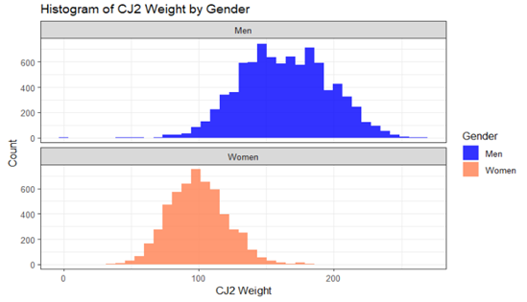
4.1.2 Load choice analysis
Figure 1: Range of chosen loads of the Clean and Jerk 2 lifts

We note that there is generally a different pattern in load choices and jumps for all lifts between men and women. Figure 1 shows the range of chosen loads for Clean and Jerk 2 lift as a sample. We note a difference in the range of lifts, with men having a much bigger range of choices and a generally higher average naturally. Similar patterns were obtained for all other lifts.

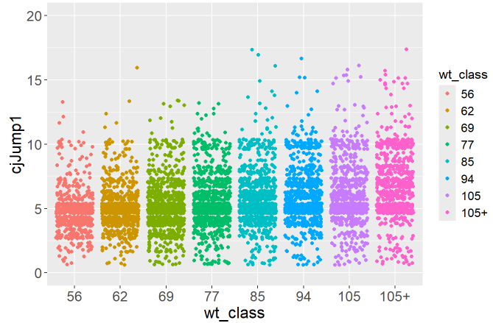  - Men | 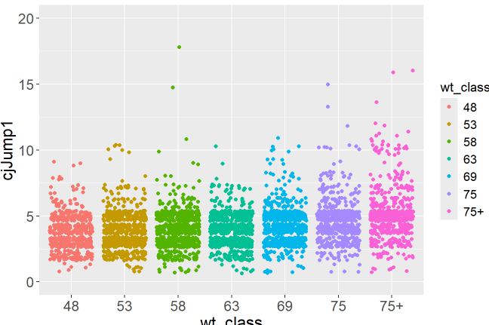  - Women
Figure 2: Clean and jerk jump 1 comparison across different weight classes

Another difference between the sexes is their choice of the jump in loads between lifts, with men mostly going for a jump of 5-10 kgs and women between 3-5 kgs. While the range of attempts from men to women showed a noticeable difference, the trend between higher jumps and having higher loads remained the same for both sexes. Also, the average CJ 1 jump also rises as you increase in weight classes. Figure 2 shows the difference in jump choice for both sexes for the different weight classes between CJ1 and CJ2. Similar results are obtained for the other three jumps.

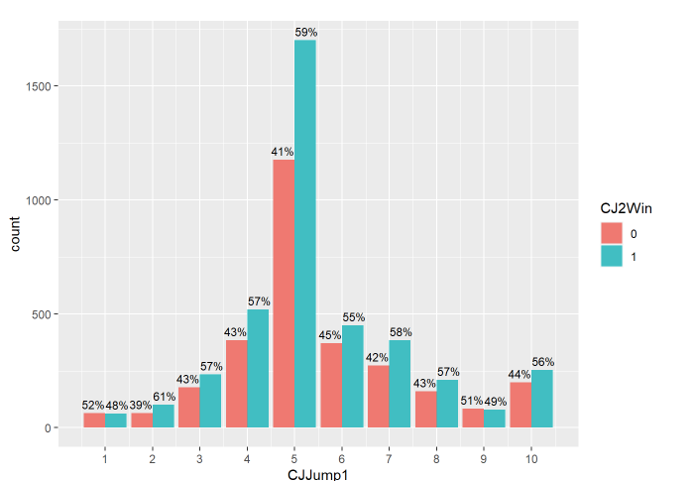  - Men | 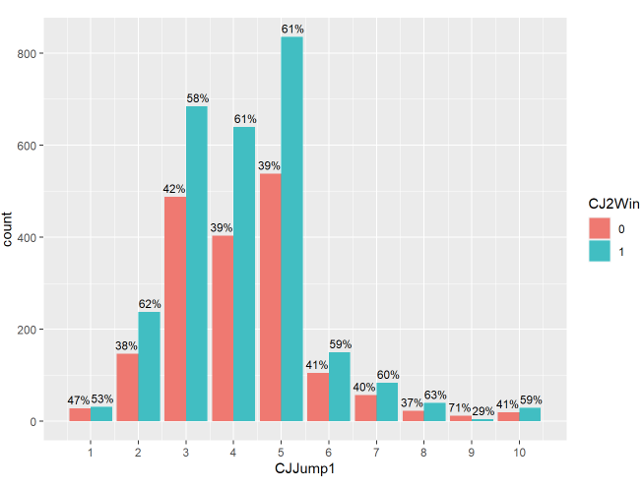  - Women
Figure 3: CJ jump 1 Success and Fail percentage across different jump choices.

In figure 3, We analyze the patterns across the different load jumps through all lifts. Each number on the x-axis shows two bar plots. A red one indicates the number of participants who attempted and failed this jump, and a blue one shows the number of participants who tried and succeeded in the jump in that load.
The blue bars with the highest percentage should be considered the safest jumps, though you must also consider the number of people who attempted it. Jumps 3-5 have the most attempts and, therefore, are a more accurate representation of your chances of succeeding or failing a jump of those loads. Figure 3 shows the results for CJ2 lift of the all-men and all-women groups as a sample. Note the strong preference for men of all weight classes for CJ1 jump1 at 5 kilos with a win rate of 59%. Women had more variety in jump choices, with most choosing 3-5 kilos.
  - Machine Learning Results

This section reviews the results of running the XGBOOST machine learning model to predict a win in all lifts for all 18 groups specified in section 3. For each model, we measured the accuracy, precision, and recall. In this section, we concentrate on the accuracy of the predictions. The complete results for accuracy, precision and recall can be found in the appendix.

As a sample, here are the results for predicting a CJ1win for women in the 75+ kg weight class:
- Confusion matrix:
Loss [ 9 9]
Win [ 6 109]
- Accuracy: 89%
- Weighted Precision: 88%
- Weighted Recall: 89%
We note the relatively good accuracy (89%) for this weight class, but our goal in this paper is not to reach a high accuracy but rather to compare the predictability of the different lifts, weight classes, and sexes.

    - Sex Differences in Predictability
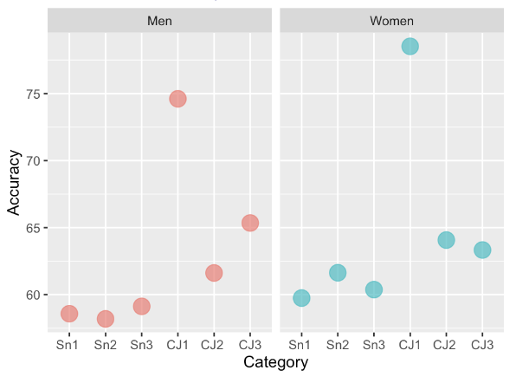
Figure 4: Comparison of accuracy of prediction for the All-men and all-women groups for all lifts
Figure 4 shows the accuracy for all lifts for our testing set's all-men and all-women groups. The mean accuracy for all-Men was 62.9%, while that of all-women was 64.6%. We note the higher prediction accuracy for women across all lifts except the last lift, CJ3. We also note an increase in prediction accuracy over the different lifts with an almost linear increase, as shown in the figure 4. The exception is the CJ1 lift, which shows a much higher prediction accuracy than the other lifts.
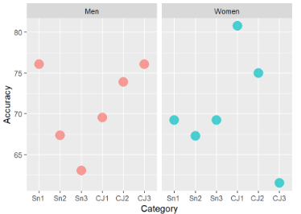
Figure 5: Comparison of accuracy of prediction for the All-men and all-women groups for all lifts during the 2024 summer Olympics

Slightly different results were obtained when we used the 2024 Olympics data as our test set, as shown in figure 5. We observe the same pattern of linear increase over lifts for women but a very different pattern for the men’s dataset. Still, the accuracy was generally much higher, with men having a slightly higher predictability: The mean accuracy for all-Men was 71.0%, while the mean accuracy for all-Women was 70.5%. Note that the Olympic dataset is much smaller, with 98 athletes, so the results are limited.

4.2.2 Weight Class Differences in Predictability

Figure 6 shows the accuracy of prediction for all weight classes, ordered by weight class. We observe the mean accuracy for women’s weight classes (dark blue trend line) was, on average, higher (74.06%) than that for the men’s weight classes (purple trend line) (72.60%). Also, CJ1 had a much higher predictability than the other 5 lifts for both men and women (blue dots trace trending above all others in the chart). Moreover, a U-shaped trend line shows that the lightest and heaviest weight classes are more predictable than the middle-weight classes. The most predictable weight class among all classes for all lifts was the women 75+ kg class, as shown in figure 6B.
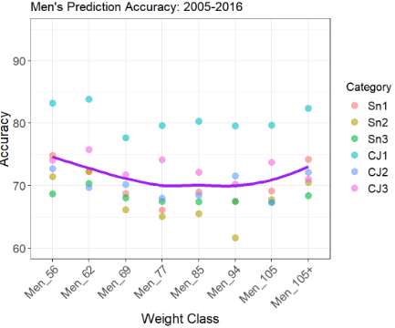  - Men | 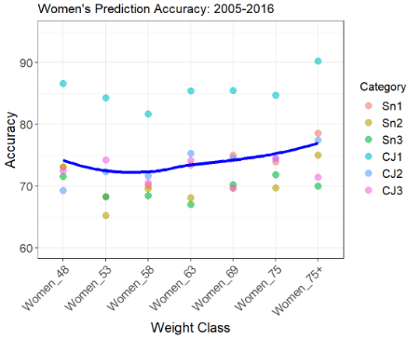  - Women
Figure 6: Accuracy results for all weight classes

Figure 7 shows the accuracy results for each weight class separately, ordered by the lifts in turn. The prediction accuracy decreases with each consecutive snatch lift and CJ lift, with the most predictable results being with CJ1. We observe a generally higher level of accuracy when each weight class is predicted separately with a much higher prediction rate in general, compared to the results of trying to predict the all-men and all-women groups, as shown in figure 4.

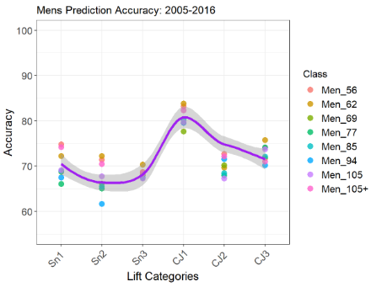  - Men | 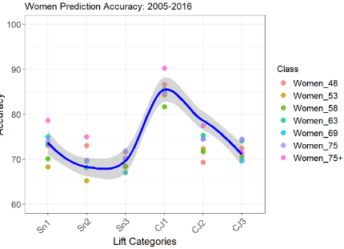  - Women
Figure 7: Accuracy results for all lifts by weight class ordered by lift

Another interesting observation is the more extensive range of accuracy measurements for female athletes across weight classes compared to the men’s weight classes as well as the generally higher accuracy of prediction for female athletes.

On running our models with the 2024 summer Olympics data as our test set, we got much better prediction results for all weight classes even though the test size was much smaller (98 athletes in most classes). A key difference was in the men’s weight classes in general. Figure 8 shows the average accuracy for the different weight classes for men & women in both the regular test set and the Olympics one. The women followed the same pattern of predictability and were generally more predictable in the Olympics, particularly with the first four lifts. The men’s weight classes, in contrast, showed a very unusual pattern with higher-than-average predictability in snatch 1, snatch 2, CJ2 & CJ3, with a significant drop in predictability for snatch 3 and CJ1.

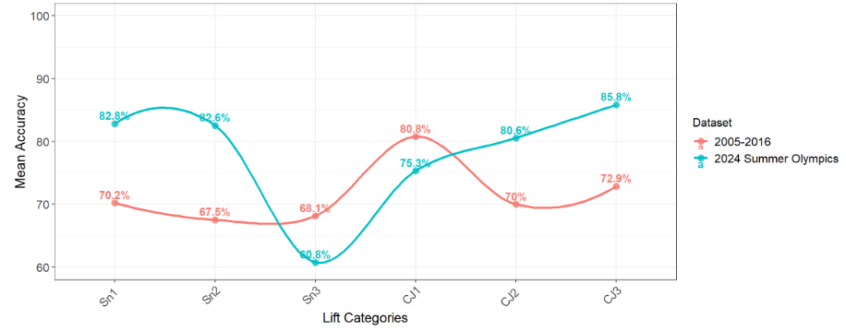
- Men
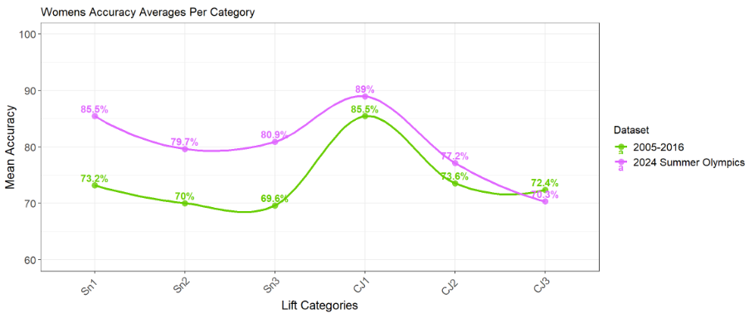
- Women
Figure 8: Accuracy of predicting the 2024 Summer Olympics results

4.2.3 Comparison of prediction among the extreme weight classes

In this section, we look at the predictability for the four weight classes with the most difference from the others: the men’s lightest weight class (56 kg), the men’s heaviest weight class (105+ kg), the women’s lightest weight class (48 kg) and the women’s heaviest weight class (75+ kg). Those are the most predictable weight classes according to figure 6. Figure 9(a) shows the accuracy for the lightest men’s weight class (orange) and the heaviest men’s weight class (green) against the average for all weight classes (blue line). We observe that both groups have a better accuracy than the average line but are relatively similar in predictability. Figure 9(b) shows the accuracy for the lightest men’s weight class (purple) and the lightest women’s weight class (yellow) against the average for all weight classes (blue line). We observe that both weight classes are more predictable than average, with the women’s weight class slightly more predictable on Snatch 2, Snatch 3, and CJ1 lifts.

Figure 9 (c) shows the accuracy for the lightest women’s weight class (yellow) and the heaviest women’s weight class (blue) against the average for all weight classes (blue line). Unlike the men’s weight class, the women’s heaviest weight class is generally more predictable than the lightest weight class. Figure 9(d) shows the accuracy for the heaviest men’s weight class (red) and the heaviest women’s weight class (yellow) against the average for all weight classes (blue line). Note the big difference in predictability, with the women’s heaviest weight class being the most predictable.

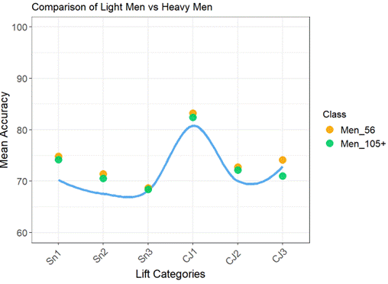 | 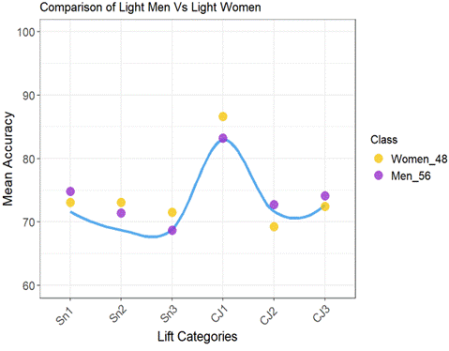
a) Lightest and heaviest men’s weight classes | b) Lightest men’s and women’s weight class
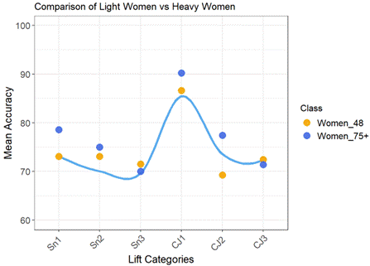 | 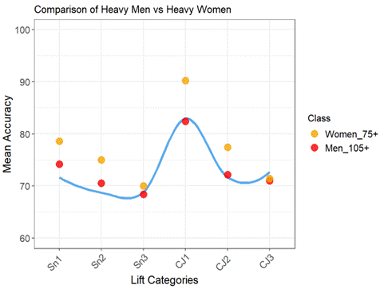
c) Lightest and heaviest women’s weight classes | d) Heaviest men’s and women’s weight class
Figure 9: Comparison of prediction accuracy for the extreme classes

4.2.4 Win and Fail precisions

In this section, we compare the win precision (percentage of all wins that were predicted as wins) and the loss precision (percentage of all losses that were predicted as losses) for the “All-men” and “All-women” groups. Figure 10(a) shows that the best win precisions are for the snatch 1 and CJ1 lifts at around 80% and go down with further lifts. On the contrary, Figure 10(b) shows that the best loss precision is snatch 3 and CJ3 (around 65%), which is generally much lower than the win precision. Figure 10(c) shows the weighted precision for both groups, and we notice that in all three charts, women are consistently more predictable than men in both wins and losses.
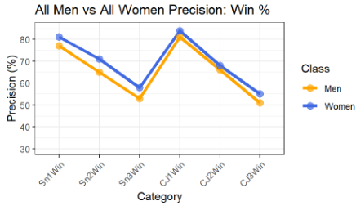
- Win precision
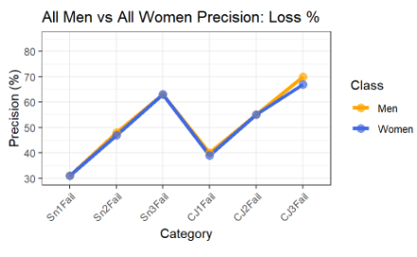
- Loss precision
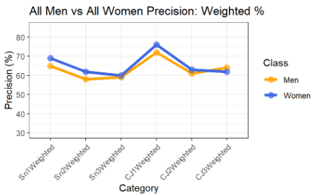
c) Weighted precision
Figure 10: Win and loss precision for the All-men and All-women groups

- Discussion
Based on the results shown in section 4, we can ascertain that using a machine learning model to predict the outcome of a lift would be a valuable tool for fast decision-making by coaches and athletes to choose a suitable load to attempt between lifts. Nonetheless, the prediction results differ for both sexes, the different lifts, competition levels, and weight classes. We present four outcomes from this work:
- Women weightlifting athletes are generally more predictable, according to figures 4, 6 and 10. This is observable in all weight classes as well as in the all-women group.
- The accuracy and precision of prediction differ a lot by the different lifts, according to figures 4, 7 and 10. Generally, the CJ1 lift for all weight classes is the most predictable. The XGBOOST model performs better when predicting success for lifts Snatch 1 and Clean and Jerk 1, as well as when it predicts a fail for lifts Snatch 3 and CJ 3.
- When using the 2024 summer Olympics as a test set, we noted that our model performed much better on this data set than our testing dataset, with a prediction of up to 89% for some weight classes. Also, we note that women athletes' results had a similar pattern but better prediction results across lifts compared to the regular test set. Meanwhile, the men athletes showed a different pattern when competing in the Olympics, with the Clean and Jerk 3 lift being the most predictable.
- Generally, the most predictable classes are the lightest and heaviest weight classes for both male and female athletes. The women’s 75+ kg weight class was generally the most predictable in load selection success for all lifts, with highly unpredictable lifts in Snatch 3 and more predictable ones in CJ3.

It would be interesting to train an ML model to predict performance based on the individual's history of lifts in previous competitions as well, but that is out of the scope of this paper and is our future work after collecting historical public data for the different athletes over multiple levels of competition and time, thereby giving a temporal view of their performance as well.
- Conclusion
In this paper, we develop a machine learning XGBOOST predictor to predict the success of a weight lift based on the athletes’ sex, weight class, age, competition level, previous loads, and previous wins. The model was trained with a large dataset of over 14,000 records collected over 11 years. The results of the 2024 Summer Olympics were also used to test our model. We observed that the quality of the prediction varies significantly among the different weight classes, sexes, and lifts. We conclude that it is best to base the prediction on having each weight class separately, even though we would have a smaller dataset. Also, women’s performance outcomes are generally more predictable than men's. We observed that, in general, the lightest and heaviest weight classes for each sex have the most predictable performance, with the women’s 75+ kg class the most predictable in general. Also, the model predicts success better than failure in the Snatch 1 and Clean and Jerk 1 lifts and does best in the Snatch 3 and Clean and Jerk 3 when predicting failure of a lift. We recommend practitioners should use the model to help when preparing tactics for competition.

References
- Reis, F. J., Alaiti, R. K., Vallio, C. S., & Hespanhol, L.: Artificial intelligence and machine-learning approaches in sports: Concepts, applications, challenges, and future perspectives. Brazilian Journal of Physical Therapy, 101083 (2024)
- Pillitteri, G., Petrigna, L., Ficarra, S., Giustino, V., Thomas, E., Rossi, A., ... & Battaglia, G.: Relationship between external and internal load indicators and injury using machine learning in professional soccer: a systematic review and meta-analysis. Research in sports medicine, 32(6), 902-938 (2024)
- Senbel, S., Artan, N. S., Taber, C., Long, S. A., Sharma, S., Kandawala, M., ... & Kaya, T.: An Evaluation of the Determinants of Performance in NCAA Division I Women’s Basketball: A Dual-Season Investigation. In International Sports Analytics Conference and Exhibition (pp. 228-234). Cham: Springer Nature Switzerland (2024)
- Felice, F., & Ley, C.: Predicting handball matches with machine learning and statistically estimated team strengths. Journal of Sports Analytics, 11 (2025)
- de Leeuw, A. W., van der Zwaard, S., van Baar, R., & Knobbe, A.: Personalized machine learning approach to injury monitoring in elite volleyball players. European journal of sport science, 22(4), 511-520 (2022)
- Chiu, L. Z., & Schilling, B. K.: A primer on weightlifting: From sport to sports training. Strength & Conditioning Journal, 27(1), 42-48 (2005)
- Zaras, N., Stasinaki, A. N., Spiliopoulou, P., Hadjicharalambous, M., & Terzis, G.: Lean body mass, muscle architecture, and performance in well-trained female weightlifters. Sports, 8(5), 67 (2020)
- Ford, L. E., Detterline, A. J., Ho, K. K., & Cao, W.: Gender-and height-related limits of muscle strength in world weightlifting champions. Journal of Applied Physiology, 89(3), 1061-1064 (2000)
- Garhammer, J., & Takano, B.: Training for weightlifting. Strength and power in sport, 2 (2003)
- Ball, R., & Weidman, D.: Analysis of USA powerlifting federation data from January 1, 2012–June 11, 2016. The Journal of Strength & Conditioning Research, 32(7), 1843-1851 (2018)
- Chavda, S., Comfort, P., Lake, J. P., Bishop, C., & Turner, A. N.: Predicting weight category–specific performance zones for Olympic, world, and European weightlifting competitions. The Journal of Strength & Conditioning Research, 37(10), 2038-2045 (2023)
- Chau, V. H.: Powerlifting score prediction using a machine learning method. Mathematical Biosciences and Engineering, 18(2), 1040-1050 (2021)
- Xiang, Y., Cruz, J., Zaman, R., & Yang, J.: Multi-objective optimization for two-dimensional maximum weight lifting prediction considering dynamic strength. Engineering Optimization, 53(2), 206-220 (2021)
- Kauhanen, H., Komi, P., & Häkkinen, K.: Standardization and validation of the body weight adjustment regression equations in Olympic weightlifting. The Journal of Strength & Conditioning Research, 16(1), 58-74 (2002)

Appendix

Table 4: XGBOOST prediction metrics for the all-men group and the men’s weight classes
 | Men only  (9089 Records) | Men 56 kg  (731 Records) | Men 62 kg  (1041 Records) | Men 69 kg  (1343 Records) | Men 77 kg  (1458 Records) | Men 85 kg  (1303 Records) | Men 94 kg  (1198 Records) | Men 105 kg  (1069 Records) | Men 105+ kg  (946 Records)
Snatch 1 Accuracy | 59% | 75% | 72% | 69% | 66% | 69% | 68% | 69% | 74%
Snatch 2 Accuracy | 58% | 71% | 72% | 66% | 65% | 66% | 62% | 68% | 71%
Snatch 3 Accuracy | 59% | 69% | 70% | 68% | 67% | 67% | 68% | 67% | 68%
CJ1 Accuracy | 75% | 83% | 84% | 78% | 80% | 80% | 80% | 80% | 82%
CJ2 Accuracy | 62% | 73% | 70% | 70% | 68% | 68% | 72% | 67% | 72%
CJ3 Accuracy | 65% | 74% | 76% | 72% | 74% | 72% | 70% | 74% | 71%
Sn1 Fail precision | 31% | 51% | 41% | 43% | 43% | 43% | 45% | 44% | 48%
Sn1 Win Precision | 77% | 86% | 84% | 78% | 79% | 86% | 78% | 88% | 87%
Sn1 Weighted Precision | 65% | 77% | 74% | 69% | 68% | 75% | 69% | 77% | 77%
Sn2 Fail precision | 48% | 65% | 69% | 57% | 60% | 56% | 54% | 58% | 57%
Sn2 Win Precision | 65% | 76% | 74% | 75% | 69% | 73% | 68% | 73% | 78%
Sn2 Weighted Precision | 58% | 72% | 72% | 68% | 65% | 66% | 62% | 67% | 71%
Sn3 Fail precision | 63% | 70% | 72% | 72% | 73% | 71% | 72% | 69% | 69%
Sn3 Win Precision | 53% | 67% | 68% | 62% | 61% | 61% | 61% | 65% | 68%
Sn3 Weighted Precision | 59% | 69% | 70% | 68% | 68% | 67% | 68% | 67% | 68%
CJ1 Fail precision | 40% | 75% | 66% | 57% | 61% | 60% | 56% | 56% | 55%
CJ1 Win Precision | 81% | 84% | 87% | 81% | 84% | 84% | 83% | 84% | 86%
CJ1 Weighted Precision | 72% | 82% | 83% | 75% | 78% | 78% | 77% | 78% | 80%
CJ2 Fail precision | 55% | 70% | 65% | 70% | 65% | 66% | 70% | 62% | 63%
CJ2 Win Precision | 66% | 74% | 73% | 70% | 70% | 71% | 72% | 71% | 77%
CJ2 Weighted Precision | 61% | 73% | 69% | 70% | 68% | 69% | 71% | 67% | 72%
CJ3 Fail precision | 70% | 77% | 80% | 74% | 77% | 76% | 76% | 77% | 76%
CJ3 Win Precision | 51% | 67% | 66% | 63% | 66% | 62% | 56% | 66% | 64%
CJ3 Weighted Precision | 64% | 74% | 75% | 71% | 73% | 71% | 69% | 73% | 71%
Sn1 Fail recall | 46% | 63% | 50% | 42% | 53% | 65% | 50% | 75% | 63%
Sn1 Win recall | 63% | 79% | 79% | 79% | 71% | 70% | 75% | 67% | 78%
Sn1 Weighted recall | 59% | 75% | 72% | 69% | 66% | 69% | 68% | 69% | 74%
Sn2 Fail recall | 49% | 67% | 57% | 69% | 57% | 60% | 58% | 53% | 57%
Sn2 Win recall | 64% | 75% | 82% | 64% | 71% | 69% | 64% | 77% | 78%
Sn2 Weighted recall | 58% | 71% | 72% | 66% | 65% | 66% | 62% | 68% | 71%
Sn3 Fail recall | 68% | 77% | 82% | 75% | 71% | 76% | 70% | 77% | 70%
Sn3 Win recall | 48% | 58% | 53% | 59% | 63% | 55% | 64% | 55% | 67%
Sn3 Weighted recall | 59% | 69% | 70% | 68% | 67% | 67% | 68% | 67% | 68%
CJ1 Fail recall | 28% | 30% | 50% | 32% | 45% | 38% | 36% | 40% | 36%
CJ1 Win recall | 88% | 97% | 93% | 92% | 91% | 93% | 92% | 91% | 93%
CJ1 Weighted recall | 75% | 83% | 84% | 78% | 80% | 80% | 80% | 80% | 82%
CJ2 Fail recall | 53% | 62% | 60% | 58% | 61% | 68% | 56% | 56% | 58%
CJ2 Win recall | 68% | 81% | 77% | 80% | 74% | 69% | 82% | 75% | 80%
CJ2 Weighted recall | 62% | 73% | 70% | 70% | 68% | 68% | 72% | 67% | 72%
CJ3 Fail recall | 81% | 83% | 85% | 87% | 87% | 82% | 82% | 83% | 75%
CJ3 Win recall | 37% | 58% | 58% | 43% | 48% | 53% | 46% | 58% | 65%
CJ3 Weighted recall | 65% | 74% | 76% | 72% | 74% | 72% | 70% | 74% | 71%

Table 5: XGBOOST prediction metrics for the all-women group and the women’s weight classes
 | Women only  (5564 Records) | Women 53 kg  (816 Records) | Women 58 kg  (920 Records) | Women 63 kg  (940 Records) | Women 69 kg  (836 Records) | Women 75 kg  (708 Records) | Women 75+ kg  (696 Records)
Snatch 1 Accuracy | 60% | 68% | 70% | 73% | 75% | 74% | 79%
Snatch 2 Accuracy | 62% | 65% | 70% | 68% | 70% | 70% | 75%
Snatch 3 Accuracy | 60% | 68% | 68% | 67% | 70% | 72% | 70%
CJ1 Accuracy | 79% | 84% | 82% | 85% | 85% | 85% | 90%
CJ2 Accuracy | 64% | 72% | 72% | 75% | 75% | 74% | 77%
CJ3 Accuracy | 63% | 74% | 71% | 74% | 70% | 74% | 71%
Sn1 Fail precision | 31% | 43% | 42% | 49% | 48% | 42% | 40%
Sn1 Win Precision | 81% | 82% | 84% | 83% | 92% | 83% | 89%
Sn1 Weighted Precision | 69% | 72% | 74% | 75% | 82% | 74% | 81%
Sn2 Fail precision | 47% | 58% | 62% | 57% | 53% | 58% | 61%
Sn2 Win Precision | 71% | 70% | 76% | 76% | 76% | 76% | 79%
Sn2 Weighted Precision | 62% | 65% | 70% | 69% | 69% | 69% | 74%
Sn3 Fail precision | 63% | 73% | 70% | 69% | 73% | 70% | 67%
Sn3 Win Precision | 58% | 62% | 66% | 65% | 68% | 74% | 73%
Sn3 Weighted Precision | 60% | 68% | 68% | 67% | 71% | 72% | 70%
CJ1 Fail precision | 39% | 58% | 60% | 68% | 73% | 75% | 67%
CJ1 Win Precision | 84% | 89% | 86% | 89% | 87% | 85% | 93%
CJ1 Weighted Precision | 76% | 83% | 80% | 84% | 84% | 83% | 90%
CJ2 Fail precision | 55% | 68% | 66% | 74% | 68% | 71% | 68%
CJ2 Win Precision | 68% | 75% | 76% | 76% | 77% | 77% | 81%
CJ2 Weighted Precision | 63% | 72% | 72% | 75% | 74% | 74% | 77%
CJ3 Fail precision | 67% | 79% | 74% | 77% | 76% | 78% | 73%
CJ3 Win Precision | 55% | 66% | 63% | 68% | 60% | 69% | 70%
CJ3 Weighted Precision | 62% | 74% | 70% | 74% | 70% | 74% | 71%
Sn1 Fail recall | 53% | 57% | 58% | 55% | 80% | 41% | 50%
Sn1 Win recall | 62% | 72% | 74% | 80% | 73% | 84% | 84%
Sn1 Weighted recall | 60% | 68% | 70% | 73% | 75% | 74% | 79%
Sn2 Fail recall | 51% | 54% | 67% | 64% | 46% | 55% | 45%
Sn2 Win recall | 68% | 73% | 72% | 71% | 81% | 78% | 88%
Sn2 Weighted recall | 62% | 65% | 70% | 68% | 70% | 70% | 75%
Sn3 Fail recall | 63% | 71% | 73% | 66% | 64% | 80% | 71%
Sn3 Win recall | 58% | 64% | 63% | 68% | 76% | 63% | 69%
Sn3 Weighted recall | 60% | 68% | 68% | 67% | 70% | 72% | 70%
CJ1 Fail recall | 26% | 48% | 46% | 53% | 35% | 24% | 56%
CJ1 Win recall | 91% | 92% | 91% | 94% | 97% | 98% | 96%
CJ1 Weighted recall | 79% | 84% | 82% | 85% | 85% | 85% | 90%
CJ2 Fail recall | 46% | 66% | 67% | 52% | 52% | 67% | 58%
CJ2 Win recall | 76% | 77% | 75% | 89% | 87% | 80% | 87%
CJ2 Weighted recall | 64% | 72% | 72% | 75% | 75% | 74% | 77%
CJ3 Fail recall | 76% | 80% | 80% | 83% | 75% | 79% | 73%
CJ3 Win recall | 44% | 65% | 55% | 60% | 62% | 68% | 70%
CJ3 Weighted recall | 63% | 74% | 71% | 74% | 70% | 74% | 71%

