TITLE
FirstName MI. LastName¹, FirstName MI. LastName², FirstName MI. LastName³
1- Company Name
City, State/Country
ABSTRACT
[Insert abstract]
Keywords:
Corresponding author:

INTRODUCTION
[Insert introduction (use sub-headings and sub sub-headings as necessary)]

Sub-heading
[Insert text]

Next Sub-heading
[Insert text]

Sub sub-heading

Experimentation

Sub-heading
[Insert text]

Next Sub-heading
[Insert text]

Results
[Insert text]

Sub-heading
[Insert text]

Next Sub-heading
[Insert text]

Conclusions
[Insert text]

Sub-heading
[Insert text]

Next Sub-heading
[Insert text]

Sub sub-heading
[Insert text]

References
Required reference format below.
Example:
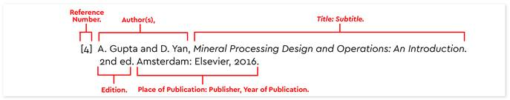

Citing a Journal Article
Wilcox, Roland. “Shifting Roles and Synthetic Women in Star Trek: The Next Generation.” Studies in Popular Culture 13(2) (1991): 53-65.

Book
Author last name, first name. Title. Place of publication: publisher, year published.
Allison, Peter. Whatever You Do, Don't Run. Guilford, CT: Lyons, 2008.

Proceedings
LastName, FirstName. “Conference Paper Title.” Conference Title. Conference location, date. Ed. Conference Editor(s). Publisher. Publication medium.

ASTM Standard
ASTM Standard D7091-05, 2005, "Standard Practice for Nondestructive Measurement of Dry Film Thickness of Nonmagnetic Coatings Applied to Ferrous Metals and Nonmagnetic, Nonconductive Coatings Applied to Non-Ferrous Metals" ASTM International, West Conshohocken, PA, 2005, DOI: 10.1520/D7091-05, www.astm.org.

Web Sites
Author. "Article Title." Publication information for a print source. Site Name. Site Editor.
Electronic publication date. Subscription information for databases. Pages only if numbered. Sponsoring Institution, City, ST or Country. Date site accessed <url>.

- [Insert reference 1] [Include DOI for which one exists]
- [Insert reference 2] [Include DOI for which one exists]

